e-Visa Group Application

Group application can be created for a minimum of 10 and a maximum of 300 people. Individuals included in the group are required to originate from the same country; their travel documents must be the same type (e.g. normal, official, diplomatic); and their arrival date must be the same (Please note that the validity period of e-Visas will begin as of the date selected as arrival date. e-Visa holders can enter Turkey on any date within the validity period. In other words, all individuals in the group are not required to enter Turkey on the same day.) In addition, all prerequisites (if any) for e-Visa application must be met by all in the group.

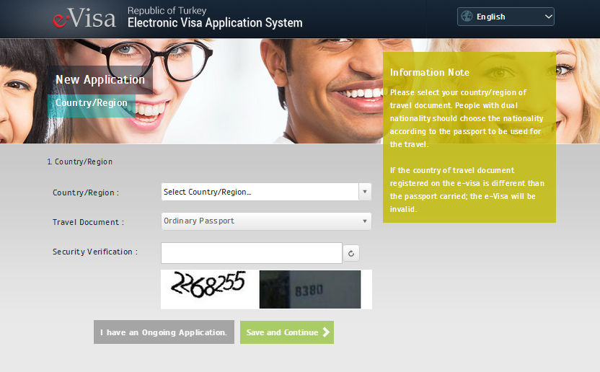

Select the related country/region of travel document on ‘Country/Region’ field, and click on ‘Save and Continue’ button. After the date selection in the ‘Date of Arrival’ section, please click on ‘Save and Continue’ button.

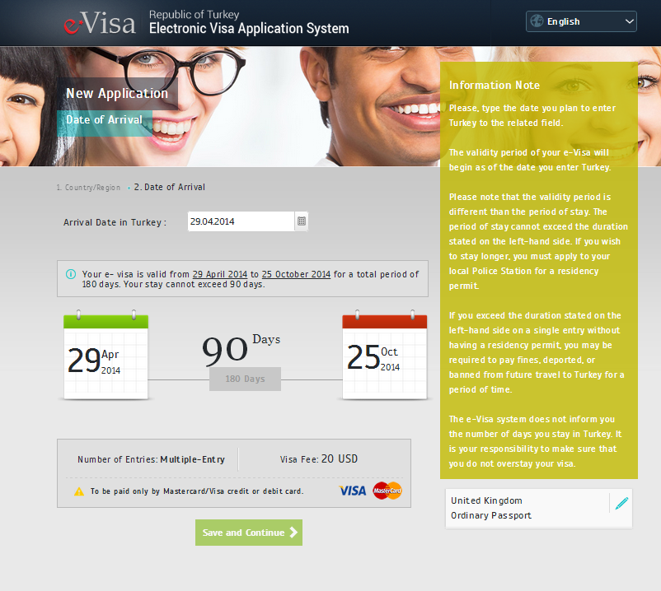

Group Application link will be displayed in the ’Information Note’ on the right of the Personal Information screen.

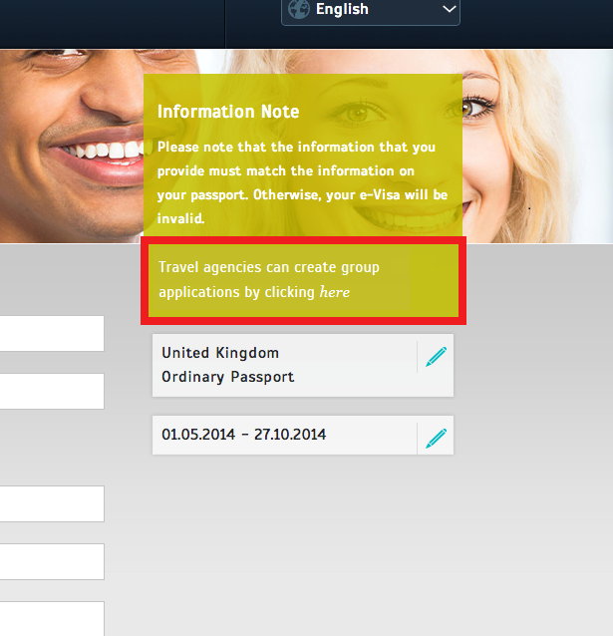

On the opening page with this link, firstly the group leader responsible for the group application will be prompted to type a valid e-mail address and contact information of the company.A verification e-mail and informative texts of the format are sent to this e-mail address.The company name is mandatory. After this stage, this email address is used at all processes related with the group application for informative purposes.

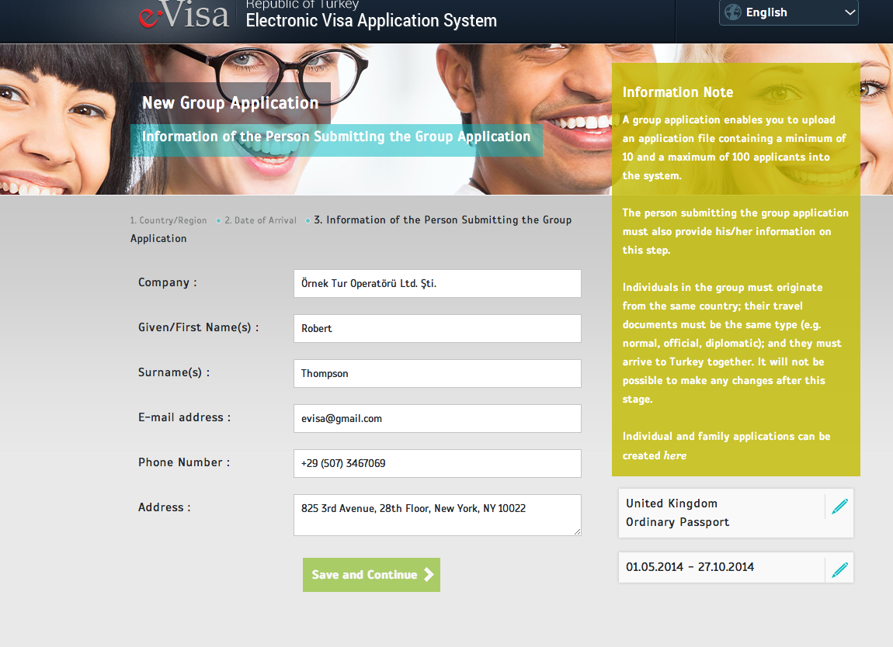

It is asked to verify the information entered. Please note that nationality, country/region of travel document, type of travel document and the validity beginning date shown on this screen will be valid in all applications. This information can not be changed for several applications in the group. In addition, the accuracy of the email address is important for the proper functioning of the application process of the entire group.

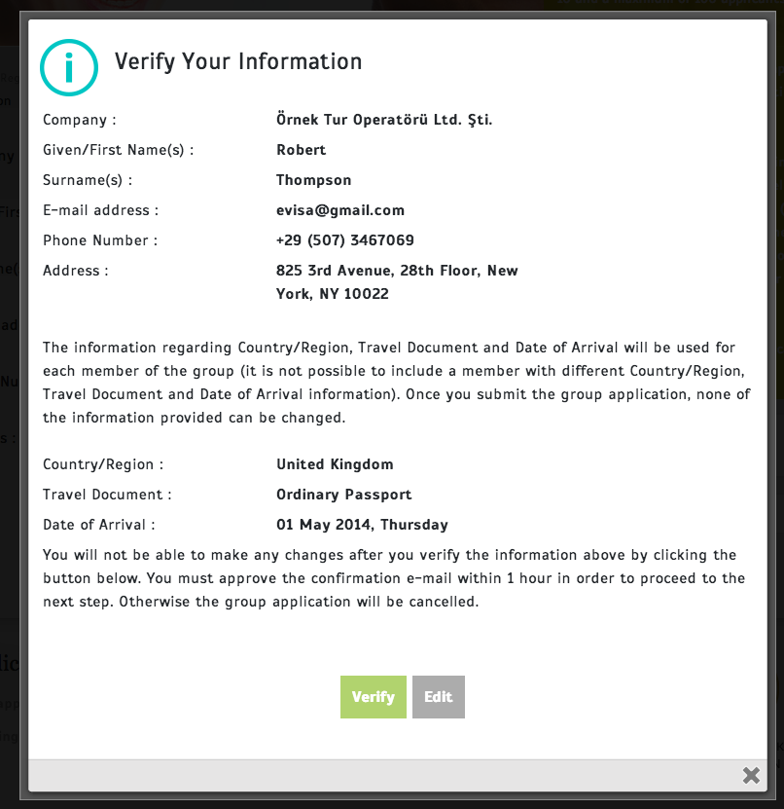

Required documents (an excel file to be filled in with the applicants’ information and a guide) will be sent to the entered e-mail address. It is not possible to upload a file in a format and with a content other than the ones containing the areas stated in the guide and group application file containing the applications saved in the format specified in the same document into the system.

Please note that the group application will time out and thus be cancelled if you do not respond to the confirmation e-mail within 1 hour. Futhermore, the group application will be deleted from the system if not completed within 48 hours.

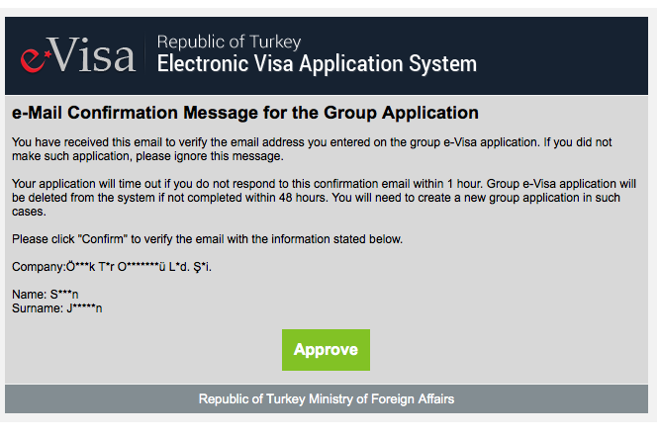

On the next stage after e-mail confirmation, the group application document which is prepared as described in the file sent by e-mail is uploaded.

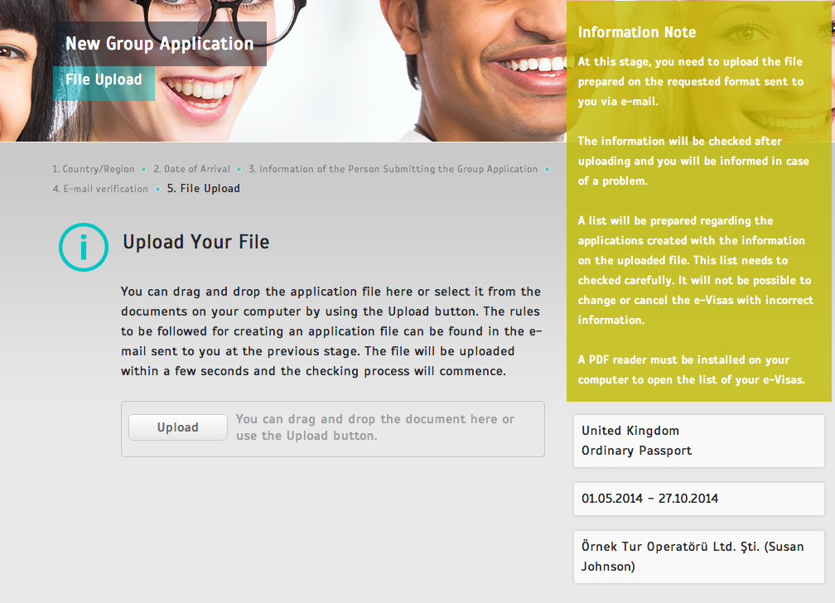

The files which are incompatible with the specified extension, format and size are rejected after uploading process and it is requested to upload a file compatible with the rules.

Also if there are format mistakes in the entered information, the user is requested to upload the file by correcting them again.

If the file is uploaded in specified rules, the process of data processing and including the information as an application to the system begins. During this process, the information of all submissions are passed through on checks individually and the list of issues that occur is shown to the person who uploaded the file on the same screen. In the error message, a list of the invalid line number and the errors found in the corresponding row is given.

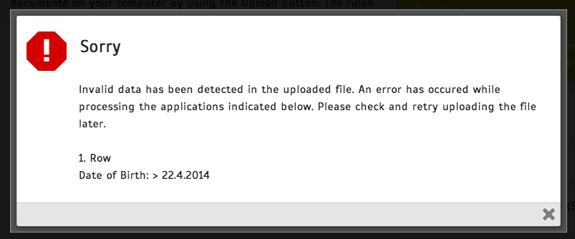

The same control procedure is repeated after error correction and files’ being reloaded. After these controls, an information message is displayed on the screen in case of successful upload. At this stage, a download button of a list of records created from uploaded information is displayed.

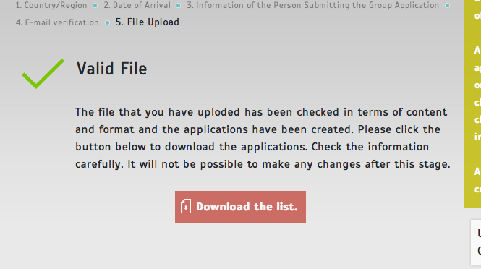

In order to continue the group application this list must be downloaded and checked. The group leader should make sure of the accuracy of all the information in the downloaded pdf file. The files should be edited and reloaded if there is any discrepancy or deficiency in this information. If there is information which is incorrect or incompatible with the actual data contained in this list , it will not be able to edit or delete this information in the ongoing phase. Therefore, it is important to control this list carefully.

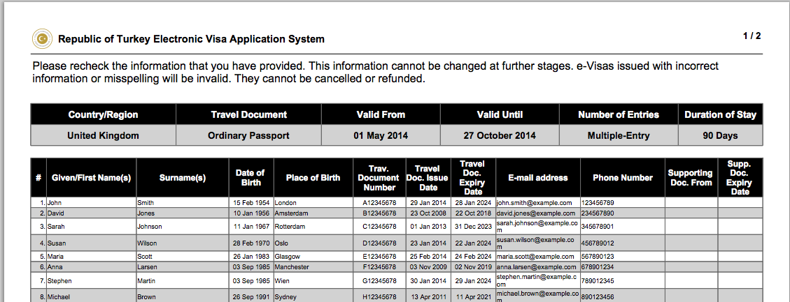

After verification of the list, the group leader will proceed to the screen where the accuracy of information is confirmed by clicking on ‘Continue’ button. On this screen common information and the accuracy of the list is confirmed.

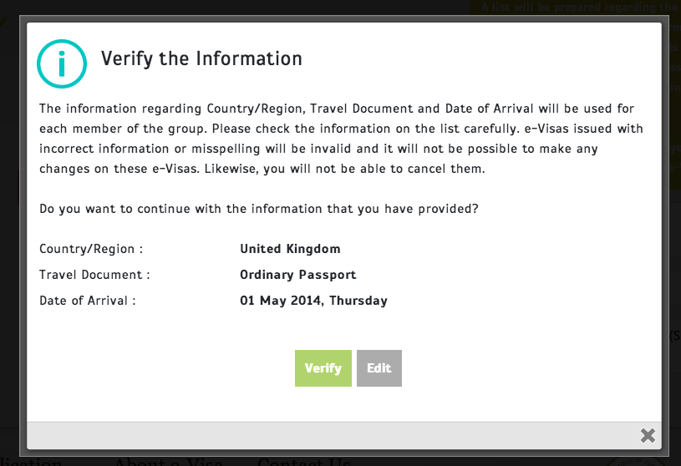

At this stage information about ongoing operation is shown in the screen and the group application starts to be processed in the background by the system.

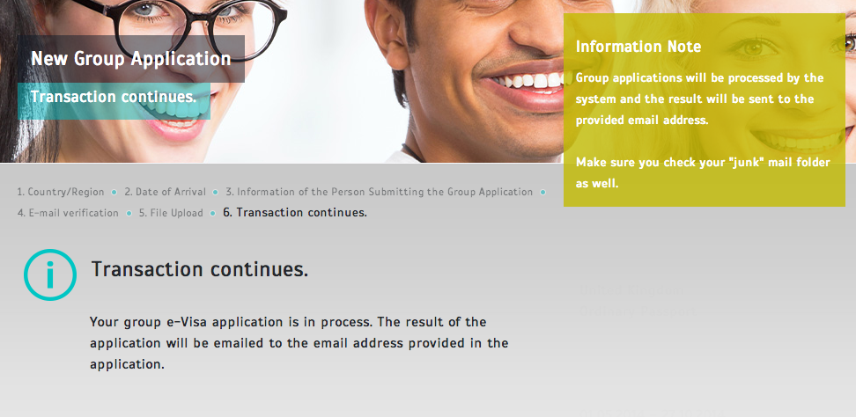

Firstly, applications are controlled from the list of exclusion order (YGY) respectively and negative results are shared with the group leader via email. If the application of one or more than one person in the group has a negative result, a link of reference on whether to continue or not is forwarded to the email address of the group leader. The total number of applications with negative results will be displayed in the page which can be accessed through this link. It is possible to proceed with the applications other than the ones(s) with negative results or cancel all applications via the buttons on the screen.

After the payment stage, the information about the applications with negative results is shared with the group leader by the system.

After the control phase, if there is any e-Visa fee to be paid, an email about this stage is shared with group leader of the application.  A lump sum payment can be made for the applications with positive results by the group leader who can reach the page by clicking the link in this email.

If country/region or type of travel document is not subject to any e-Visa fee, it will be proceeded to the next step automatically without sharing an email regarding this case.

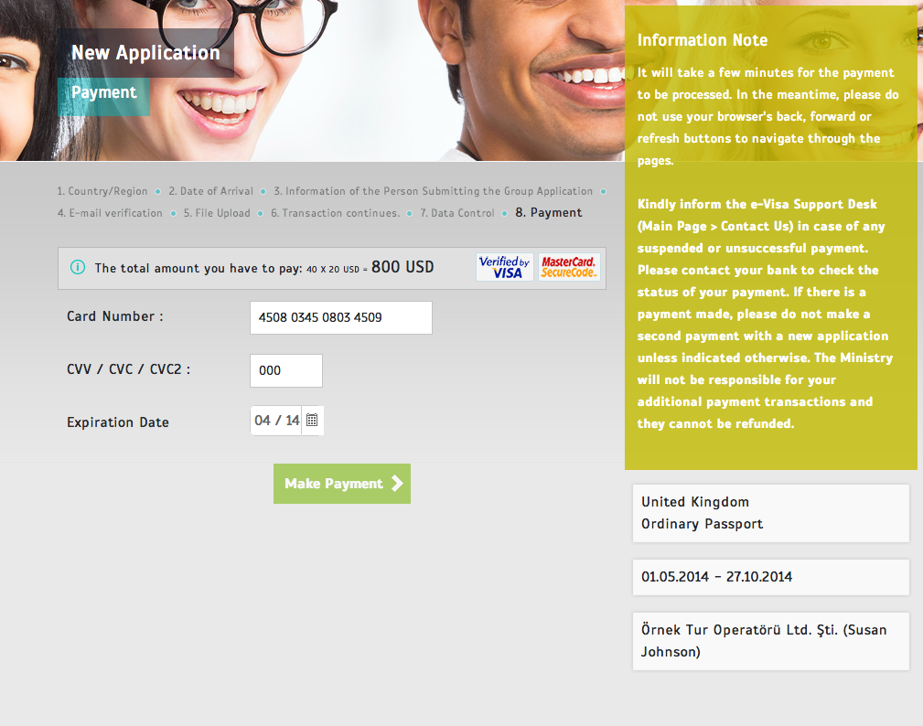

After making payment, a screen showing that the transaction still continues appeares on the screen and the e-Visas start to be prepared in the background. At the end of the e-Visa preparation process, the group leader will be informed by an e-mail again.

In the final email, the group leader can reach the link of the list of results of all the applications in the group that can be downloaded in PDF and XLS format and payment receipt will be displayed if any e-Visa fee was paid.

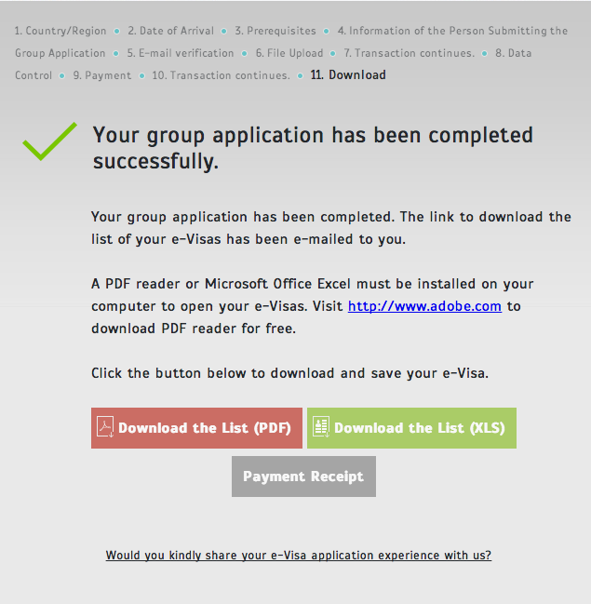

The lines belonging to negative results in the list of applications are indicated by red. In the lines of other applications issued successfully, e-Visa numbers and reference numbers are displayed.

This list of reference numbers can be shared with the applicants. In this case, when an applicant logs into the system with his/her reference number, the applicant can download the e-Visa as if he created an individual e-Visa application. However, the applicant can not print the payment receipt.

Passport control officers at the ports of entry can verify your e-Visa in their system. However, you are advised to keep your e-Visa with you either as a softcopy (on tablet pc, smartphone etc.) or as a hardcopy in case of any failure in the system. It is important to know the reference number.



For group applications, a single payment receipt can be arranged for all the applicants by only the group leader on behalf of the related company responsible for the group application.

